**CREATE TABLES for various databases using DDL commands (i.e. CREATE, ALTER, DROP, TRUNCATE)**

1. Creating a Table

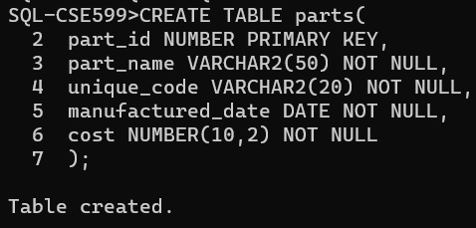

1. Describing the table,

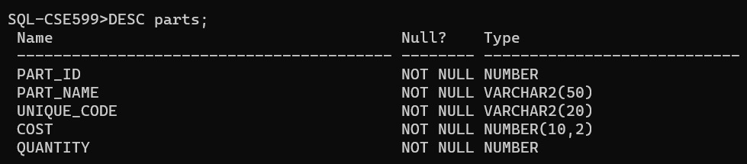

1. Altering the table,

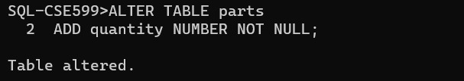

1. Describing the altered table,

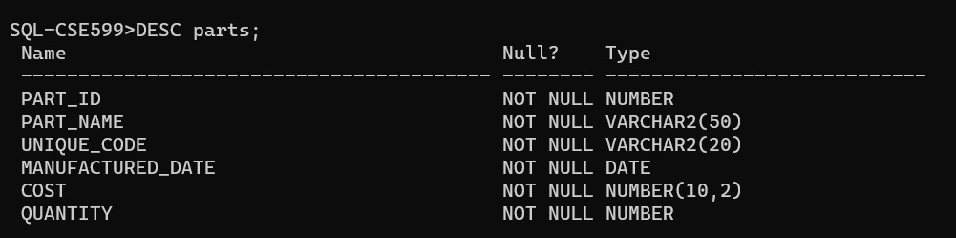

1. Creating another table,

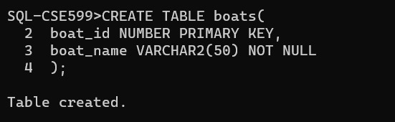

1. Drop table,

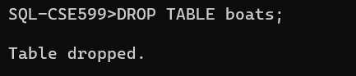

1. Truncate table,

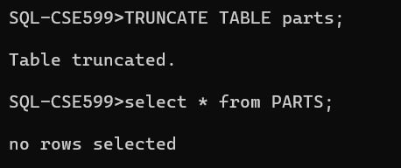

CONCLUSION:

Above operations are successfully executed.

***Write SQL queries to MANIPULATE TABLES for various databases using DML commands (i.e. INSERT, SELECT, UPDATE, DELETE,).***

Creating table :

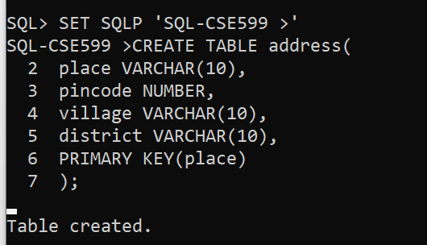

Inserting values,

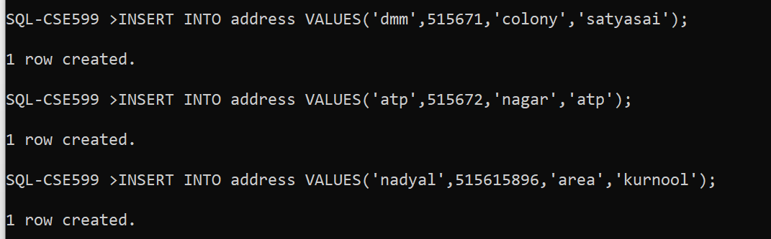

Selecting the values,

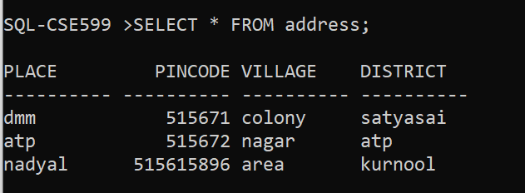

Updating the table,

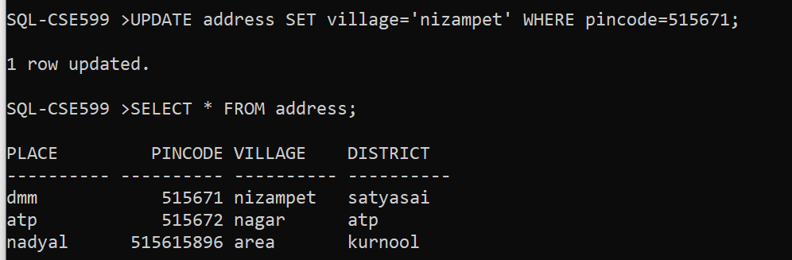

Deleting the row,

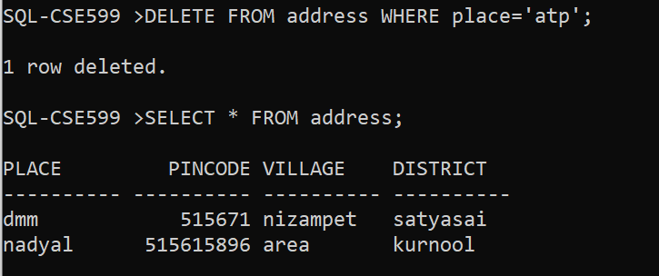

CONCLUSION:

Above operations are successfully executed.

***IMPLEMENTING VIEW LEVEL DESIGN USING DDL COMMANDS***

1. Creating a table,

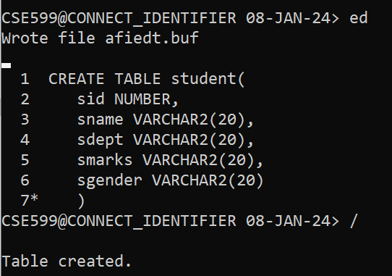

1. Inserting into table,

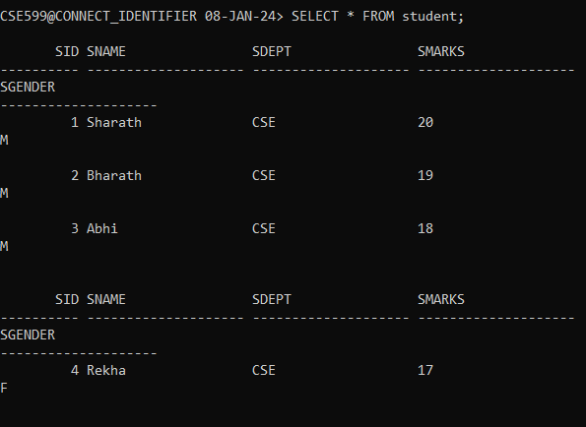

1. Creating a view,

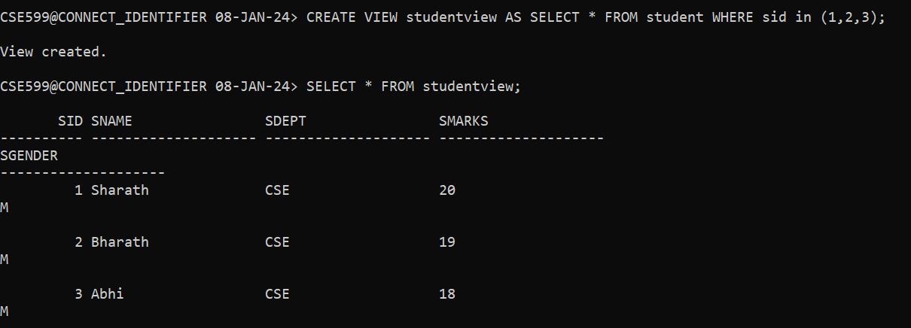

1. Updating view,

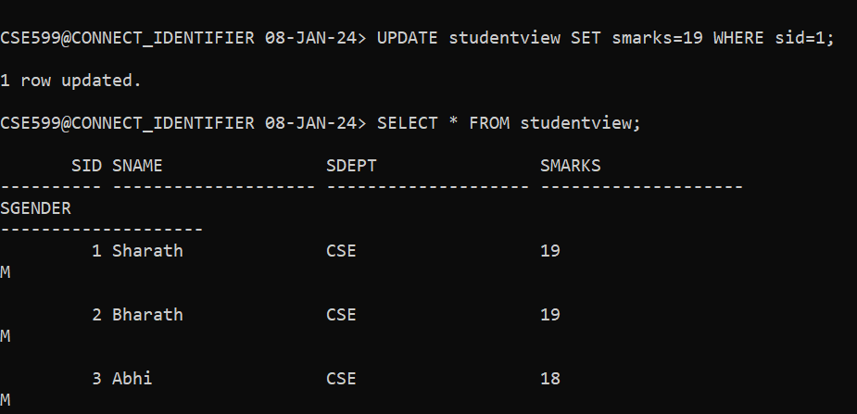

1. Deleting a view,

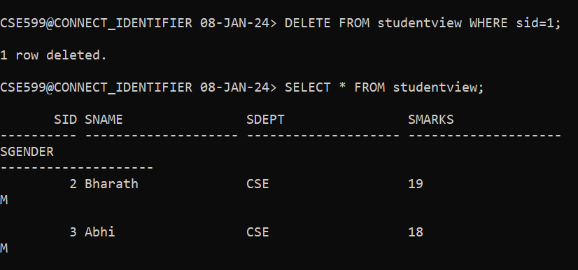

1. Drop a view,

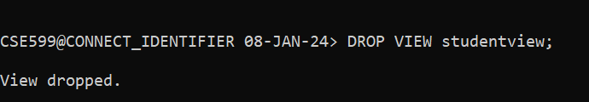

CONCLUSION:

Above operations are successfully executed.

***PERFORMING RELATIONAL SET OPERATIONS***

1. Creating a table,

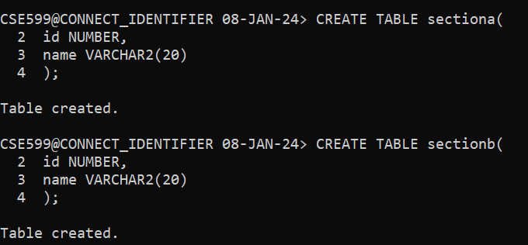

1. Inserting values into tables,

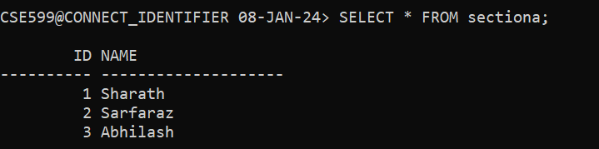

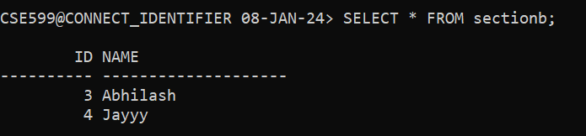

1. UNION operation,

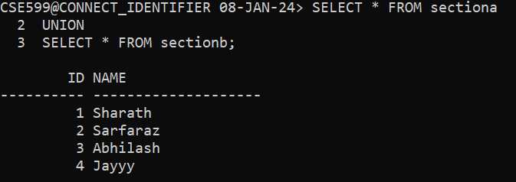

1. UNION ALL operation,

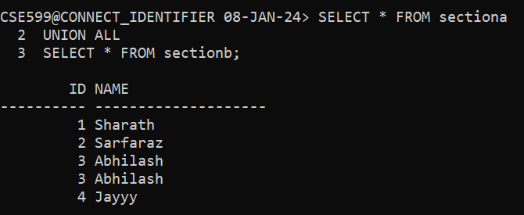

1. INTERSECT operation,

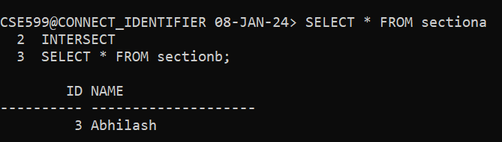

1. MINUS operation,

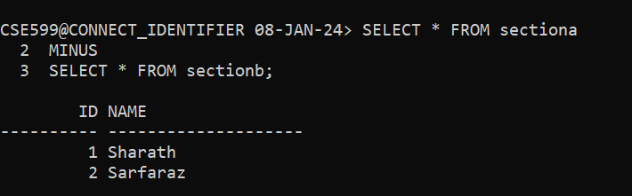

1. CROSS JOIN operation,

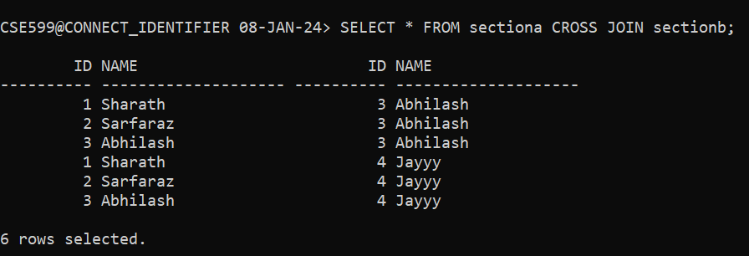

1. NATURAL JOIN operation,

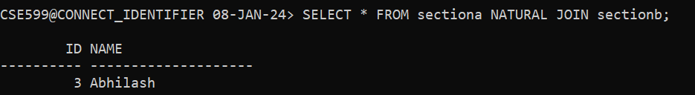

CONCLUSION:

Above operations are successfully executed.

***PERFORMING SPECIAL OPERATIONS***

1. Creating a table,

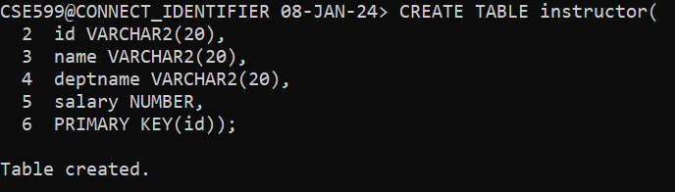

1. Inserting values into table,

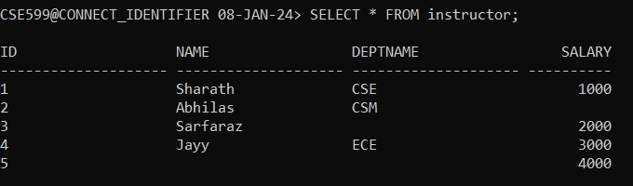

1. IS NULL operation,

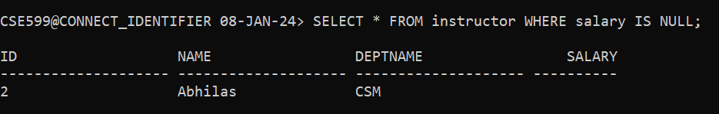

1. BETWEEN operation,

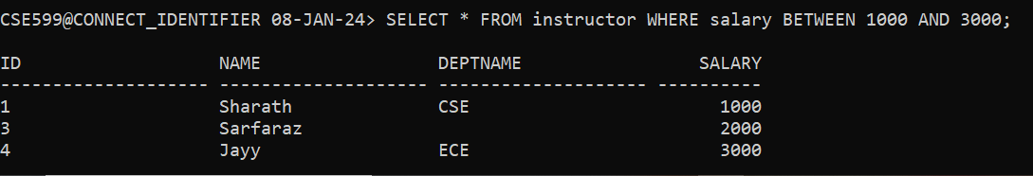

1. LIKE operation,

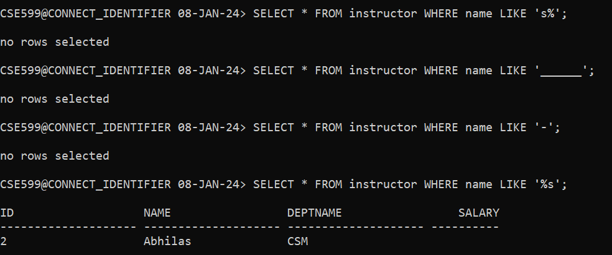

1. IN operation,

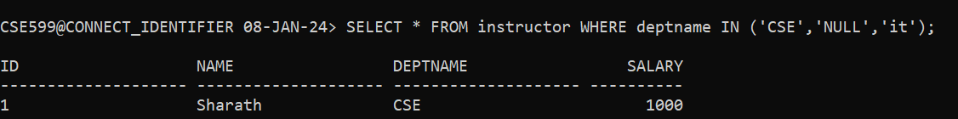

1. EXISTS operation,



CONCLUSION:

Above operations are successfully executed.

**JOIN OPERATIONS**

1. Creating a table:

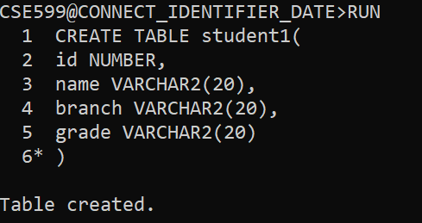

1. Insert the values:

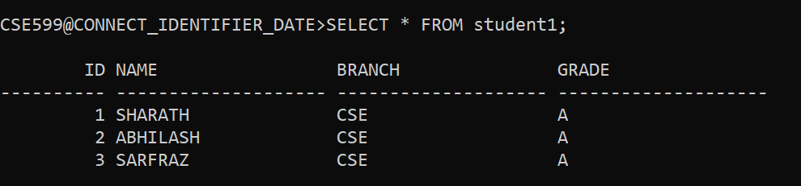

1. Creating another table:

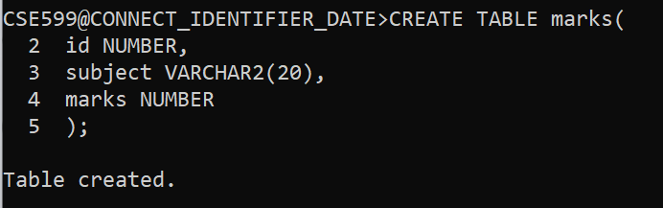

1. Insert the values:

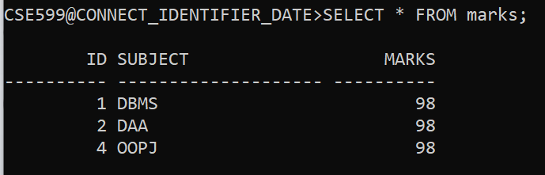

1. Conditional join:

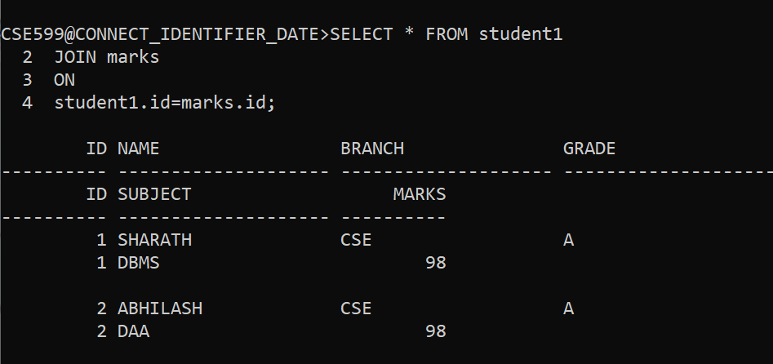

1. Left join:

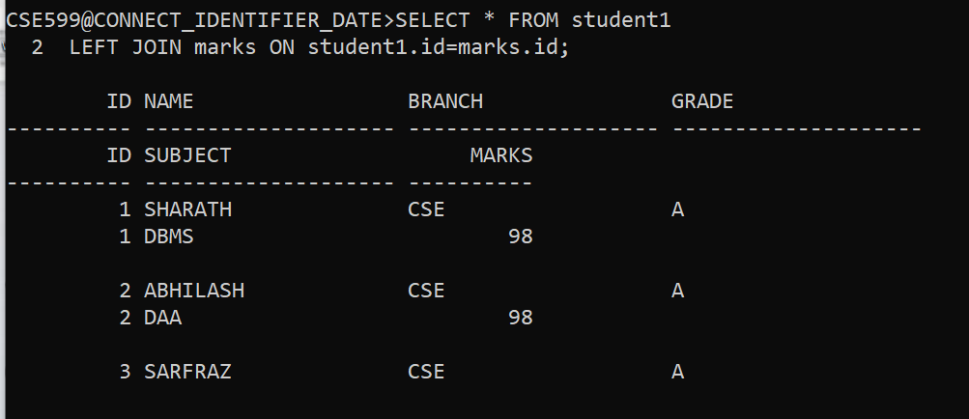

1. Right join:

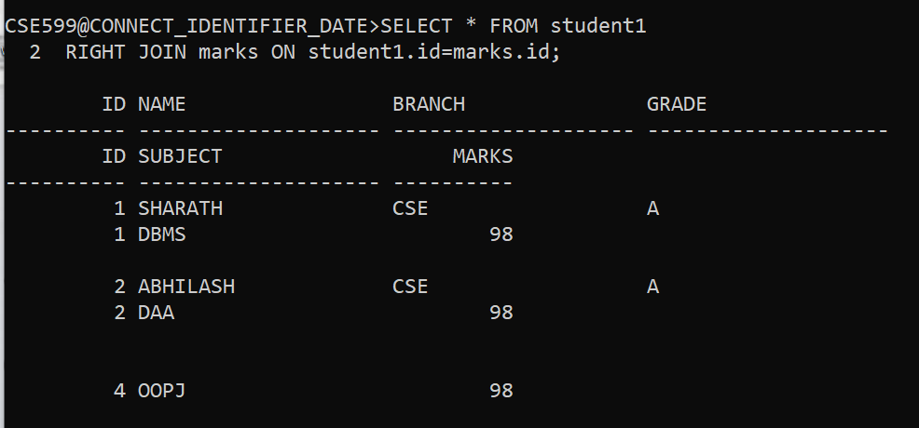

1. Full join:

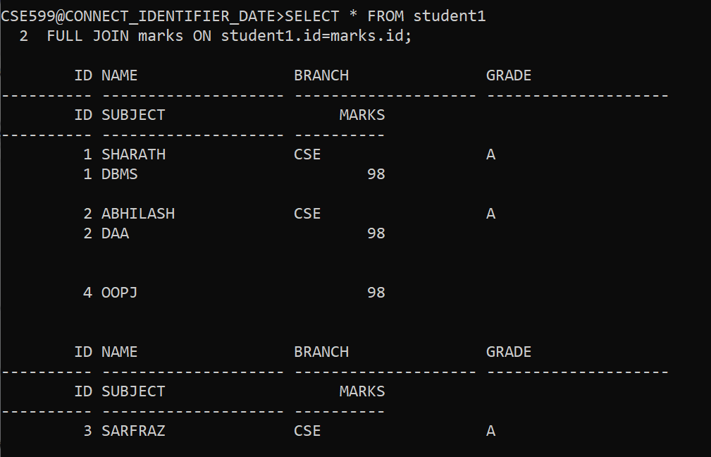

1. Equi join:

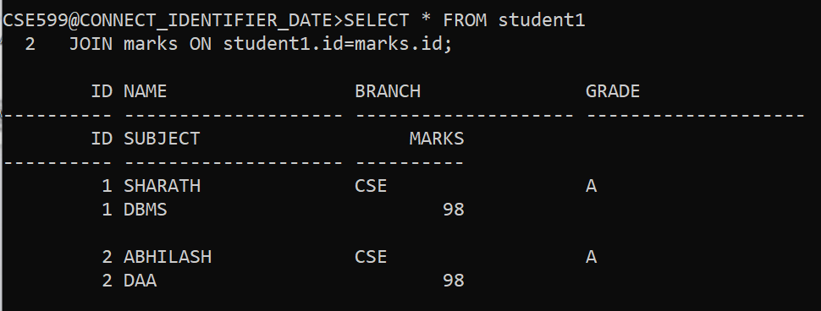

Conclusion:

Above operations are done successfully in sql.

**AGGREGATE FUNCTIONS**

1. CREATING A TABLE:

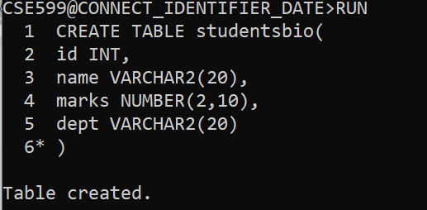

1. INSERTING THE VALUES:

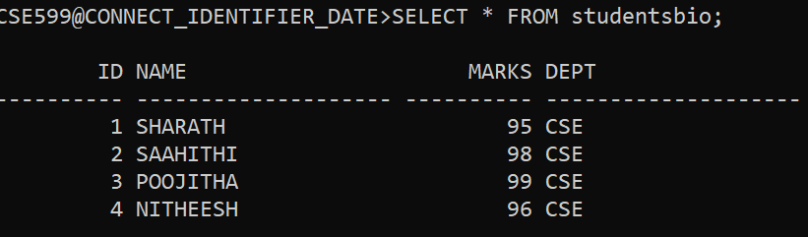

1. COUNT FUNCTION:

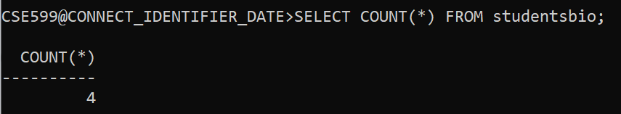

1. SUM FUNCTION:

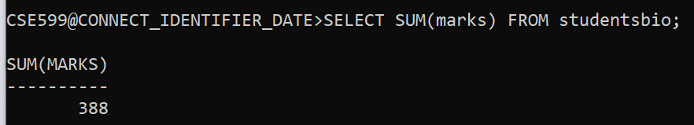

1. AVG FUNCTION:

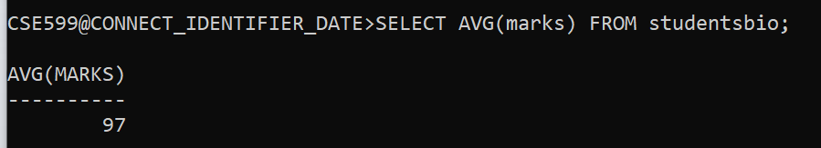

1. MAX FUNCTION:

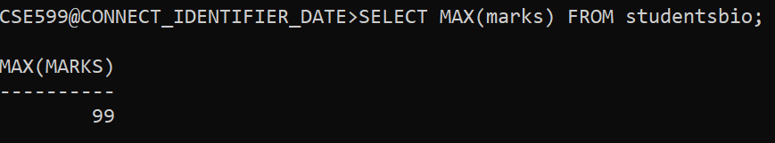

1. MIN FUNCTION:

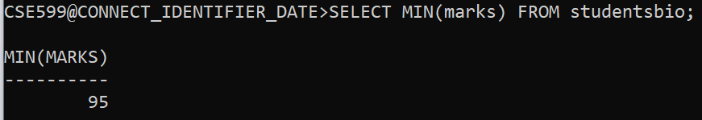

CONCLUSION:

Above operations are successfully executed.

**ORACLE BUILT IN FUNCTIONS**

**1.**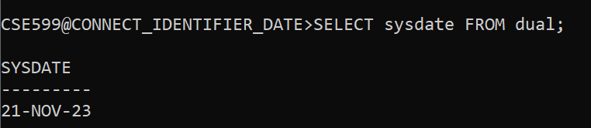

**2.**

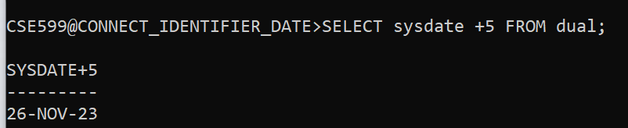

**3.**

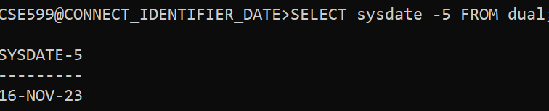

**4.**



**5.**

**6.**

**7.**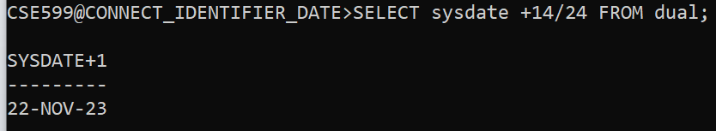

**8.**

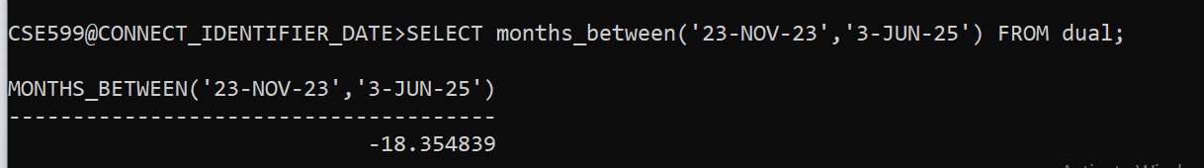

**9.**

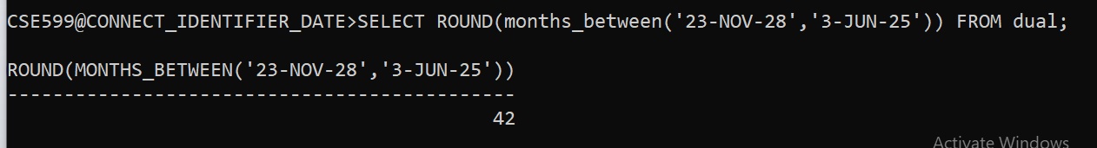

**10.**

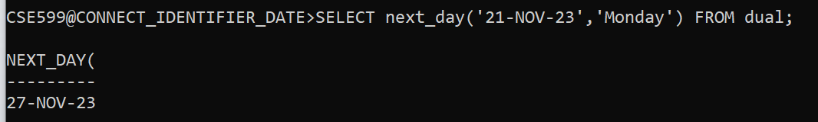

**11.**

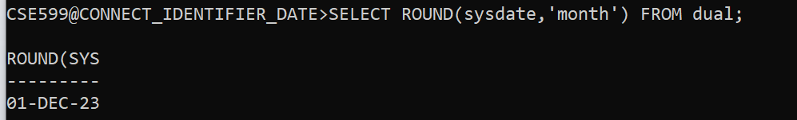

**12.**

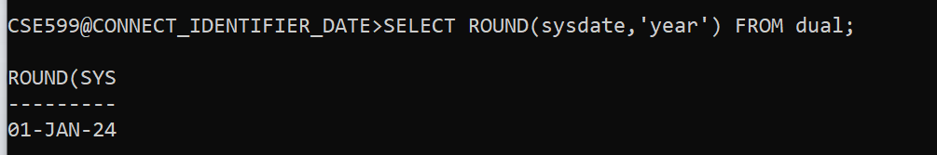

**13.**

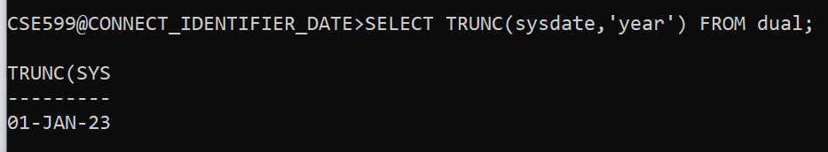

**14.**

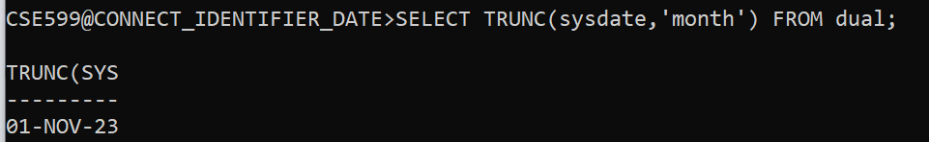

**15.**

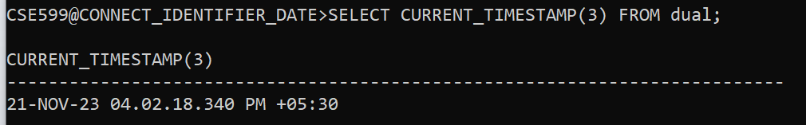

CONCLUSION:

Above operations are successfully executed.

**Perform KEY CONSTRAINTS (i.e. PRIMARY KEY, FOREIGN KEY,**

**UNIQUE NOT NULL, CHECK, DEFAULT).**

1. PRIMARY KEY,

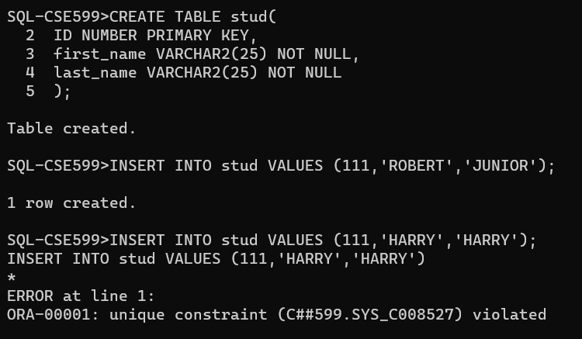

2.

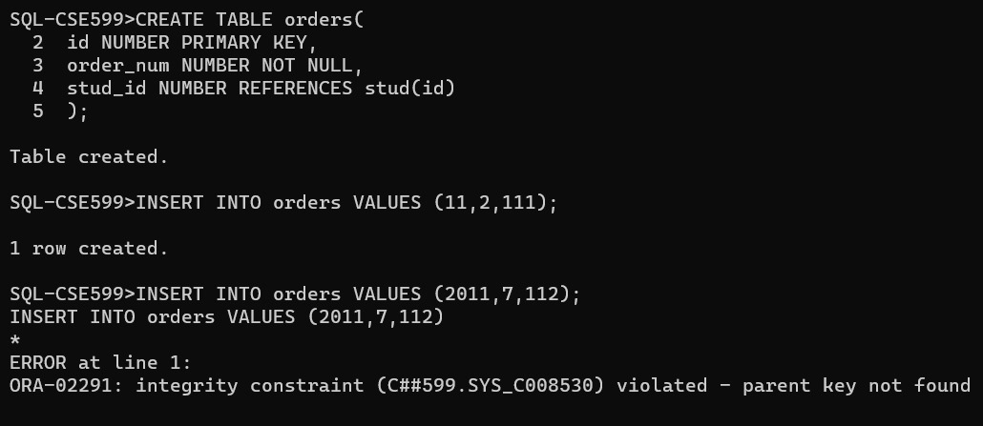

3.

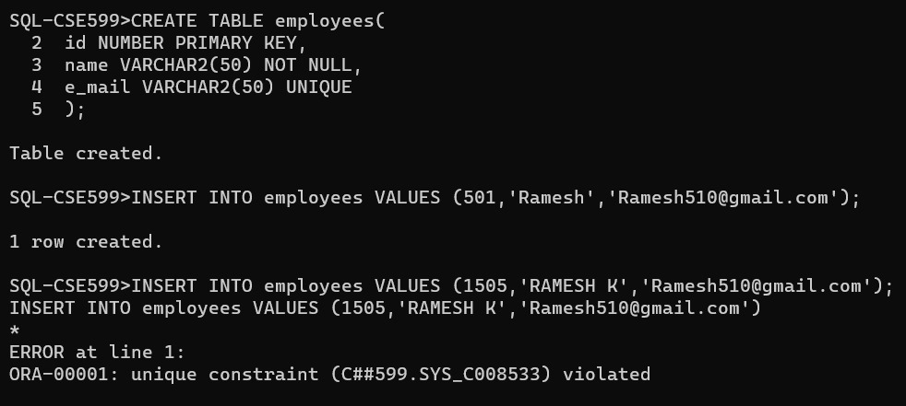

4.

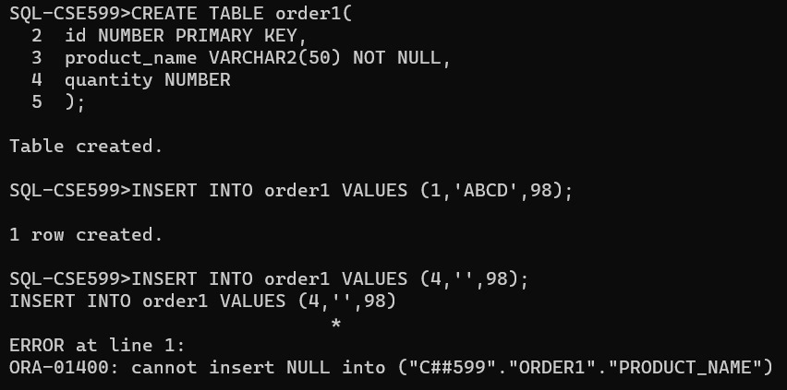

5.

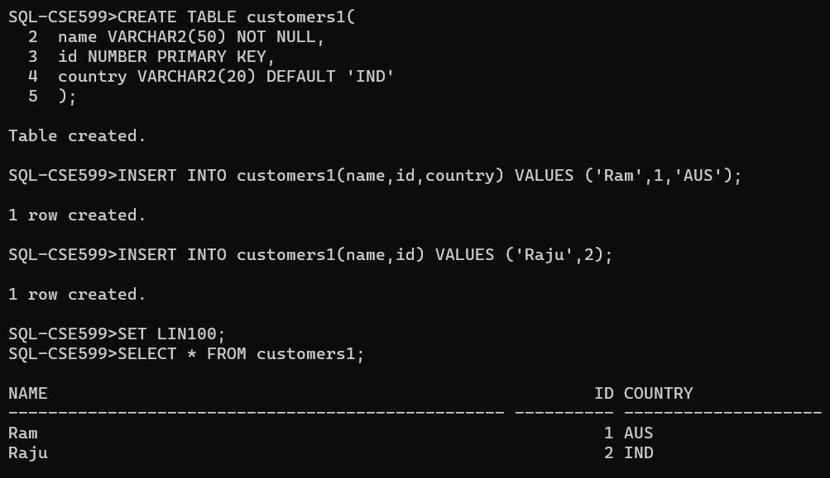

6.

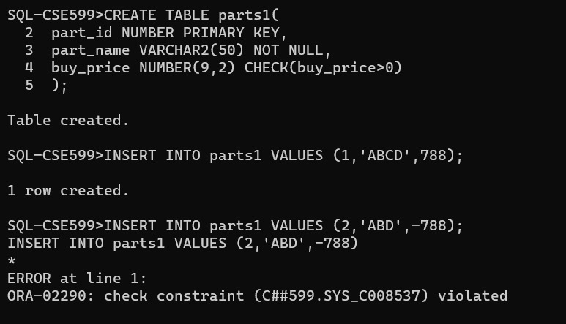

CONCLUSION:

Above operations are successfully executed.

**PL/SQL program for calculating the factorial of a given number.**

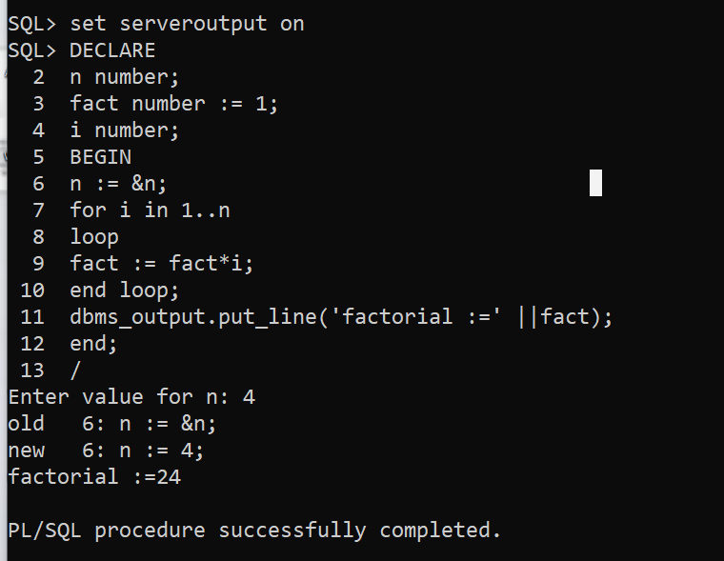

CONCLUSION:

Above pl/sql program is successfully executed.

**PL/SQL program for finding the given number is prime number or not.**

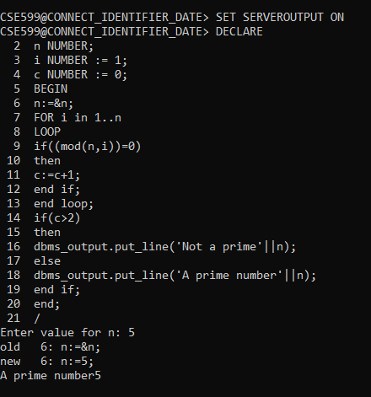

CONCLUSION:

Above pl/sql program is successfully executed.

**PL/SQL program for displaying the Fibonacci series up to an integer.**

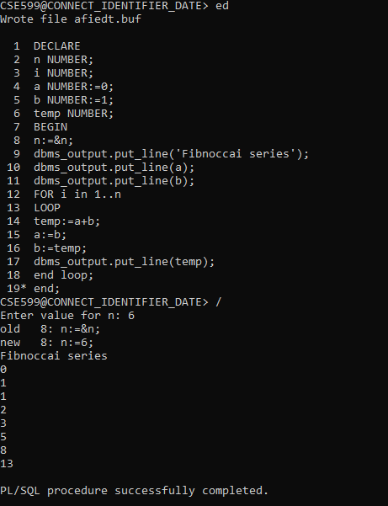

CONCLUSION:

Above pl/sql program is successfully executed.

**Write PL/SQL program to implement Stored Procedure on table.**

**1. Creating table,**

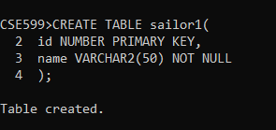

**2. Creating procedure,**

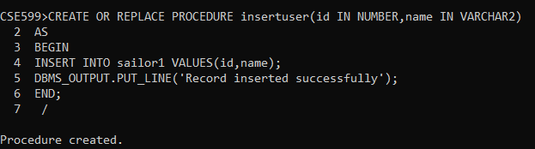

**3.Insert records into procedure,**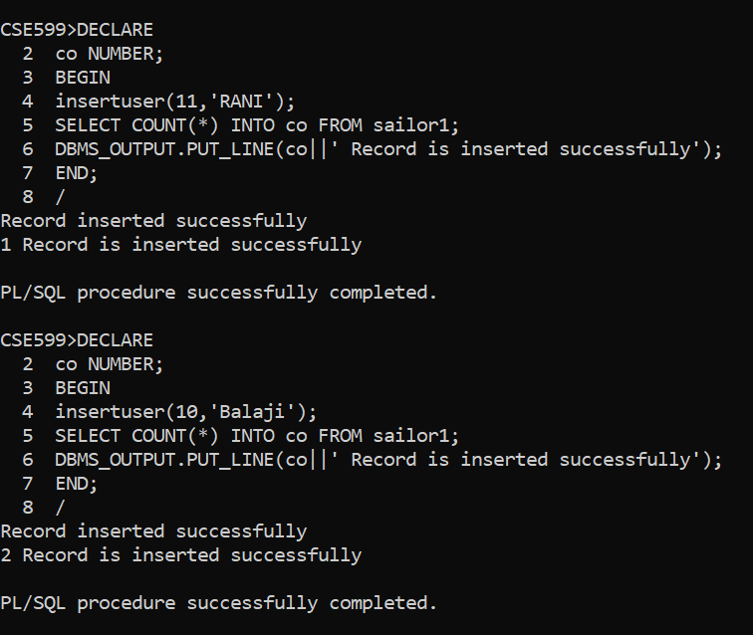

CONCLUSION:

Above pl/sql program is successfully executed.

**PL/SQL program to implement Stored Function on table.**

1.Creating table,

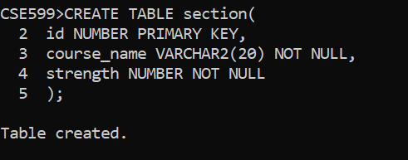

**2.**Inserting values into table,

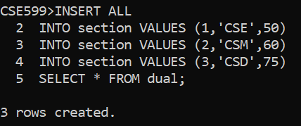

3.Creating a function,

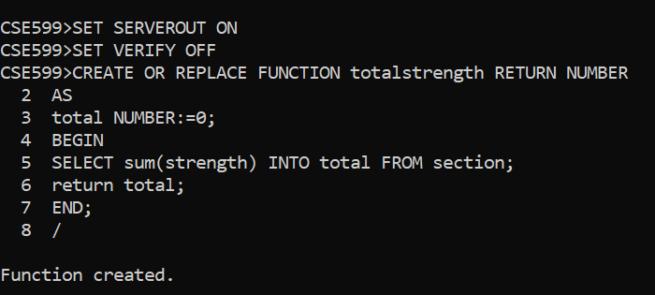

4.Displaying function,

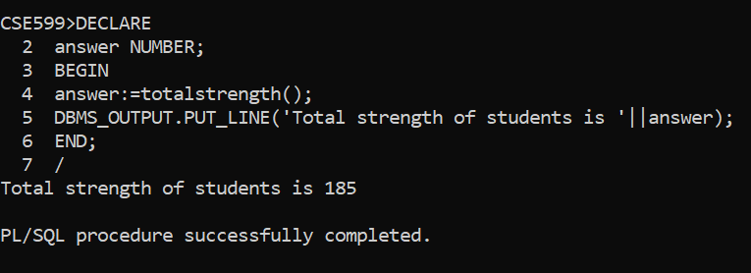

CONCLUSION:

Above pl/sql program is successfully executed

**Write PL/SQL program to implement Trigger on table.**

1.Creating a table,

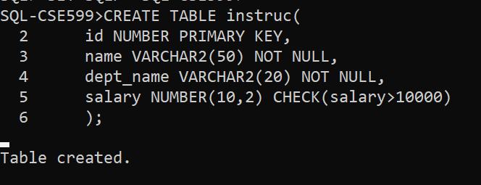

2.Inserting value,

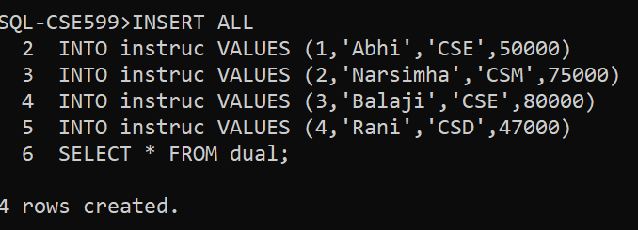

3.Creating trigger,

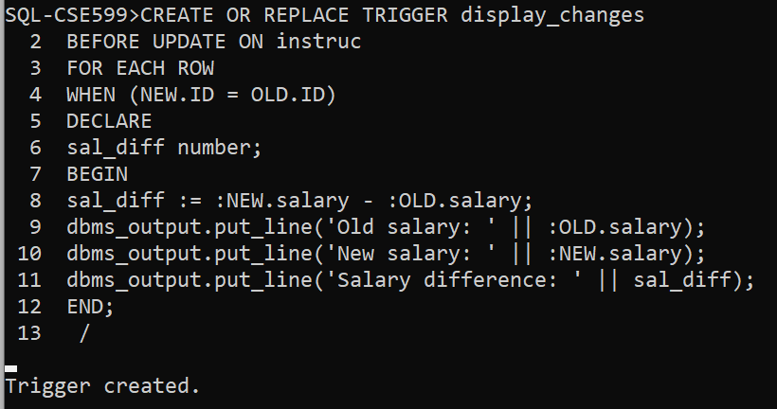

4.Displaying trigger,

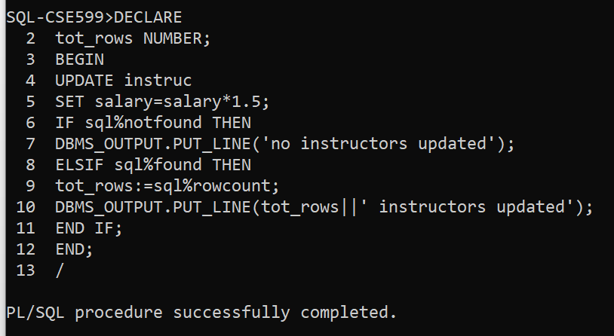

CONCLUSION:

Above pl/sql program is successfully executed.

**Write PL/SQL program to implement Cursor on table.**

**1.**Creating a table,

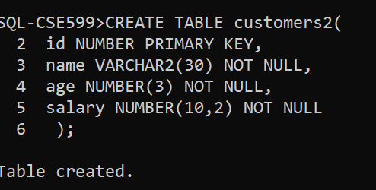

2.Implementing curser,

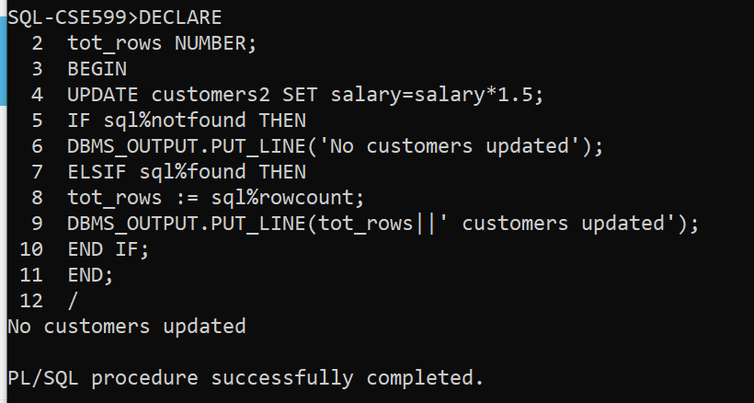

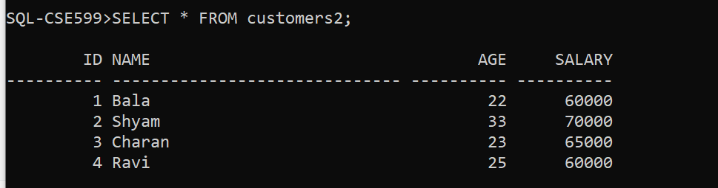

**4.**Displaying cursers,

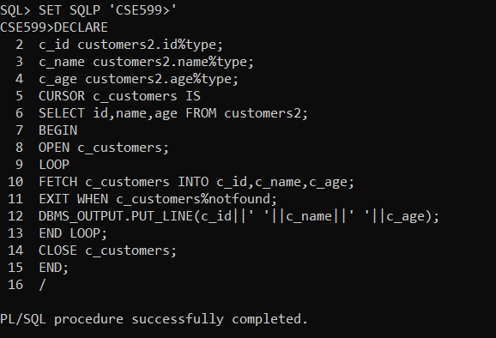

CONCLUSION:

Above pl/sql program is successfully executed.